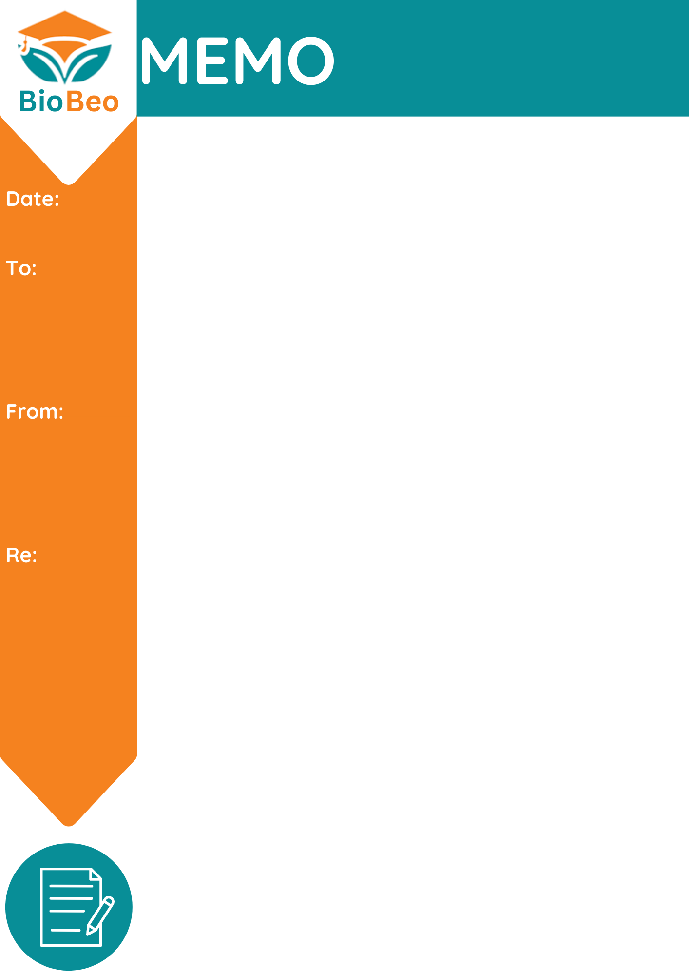

**Dissemination of Bio-Beo project and Activities to Youth Parliament**

**YSBF, Estonia**

**Youth Parliament Finland**

**04/05/2023**

**Dear Members of the Youth Parliament,**

As it is considered of potential interest, we would like to bring to your attention our recent project BioBeo.

**Project Details**

BioBeo develops and deploys an education programme that will enhance understanding and engagement across society regarding circularity and the bioeconomy. The project focuses on five bioeconomy themes: Interconnectedness, outdoor learning, forestry, life below water, and the food loop.

A sustainable network of interconnected European educators and stakeholders are co-creating the education programme and provide the means for better coordination between bio-science and education in schools. BioBeo, therefore, has a particular focus on circular lifestyle, circular behaviours, and a governance framework on society- wide engagement in bioeconomy policy.

BioBeo introduces new thinking and approaches in education on the circular economy across Europe. While strategically overcoming the institutional and cultural barriers to implementing relevant circular bioeconomy education programs in preschool, primary, and secondary schools, we are defining and delivering novel curricula in schools. Our aim is to enhance young people’s and citizens ‘involvement in policy-making for bioeconomy.

**The Objectives of Bio-Beo are**:

* ***Introducing*** new approaches to enhance how governance of education in the circular bioeconomy is tackled.
* ***Implementing*** the concept of a bioeconomy via the BioBeo education programme.
* ***Providing*** a basis for piloting the BioBeo education programme and resources in preschools, primary and secondary level schools and also in teacher education modules in university courses.
* ***Enhancing*** learner outcomes and experiences on the bioeconomy by developing a suite of digital toolkits.
* ***Developing*** the BioBeo Interconnectedness Programme with primary, secondary and university students.
* ***Demonstrating*** a measured increase in the engagement of young people and their intention to pursue education and careers in life science, technology and bioeconomy.
* ***Integrating*** the BioBeo education programme into university curricula in Ireland, Netherlands, Germany, Belgium and Greece.
* ***Coordinating*** communication and dissemination by optimising the reach and visibility.

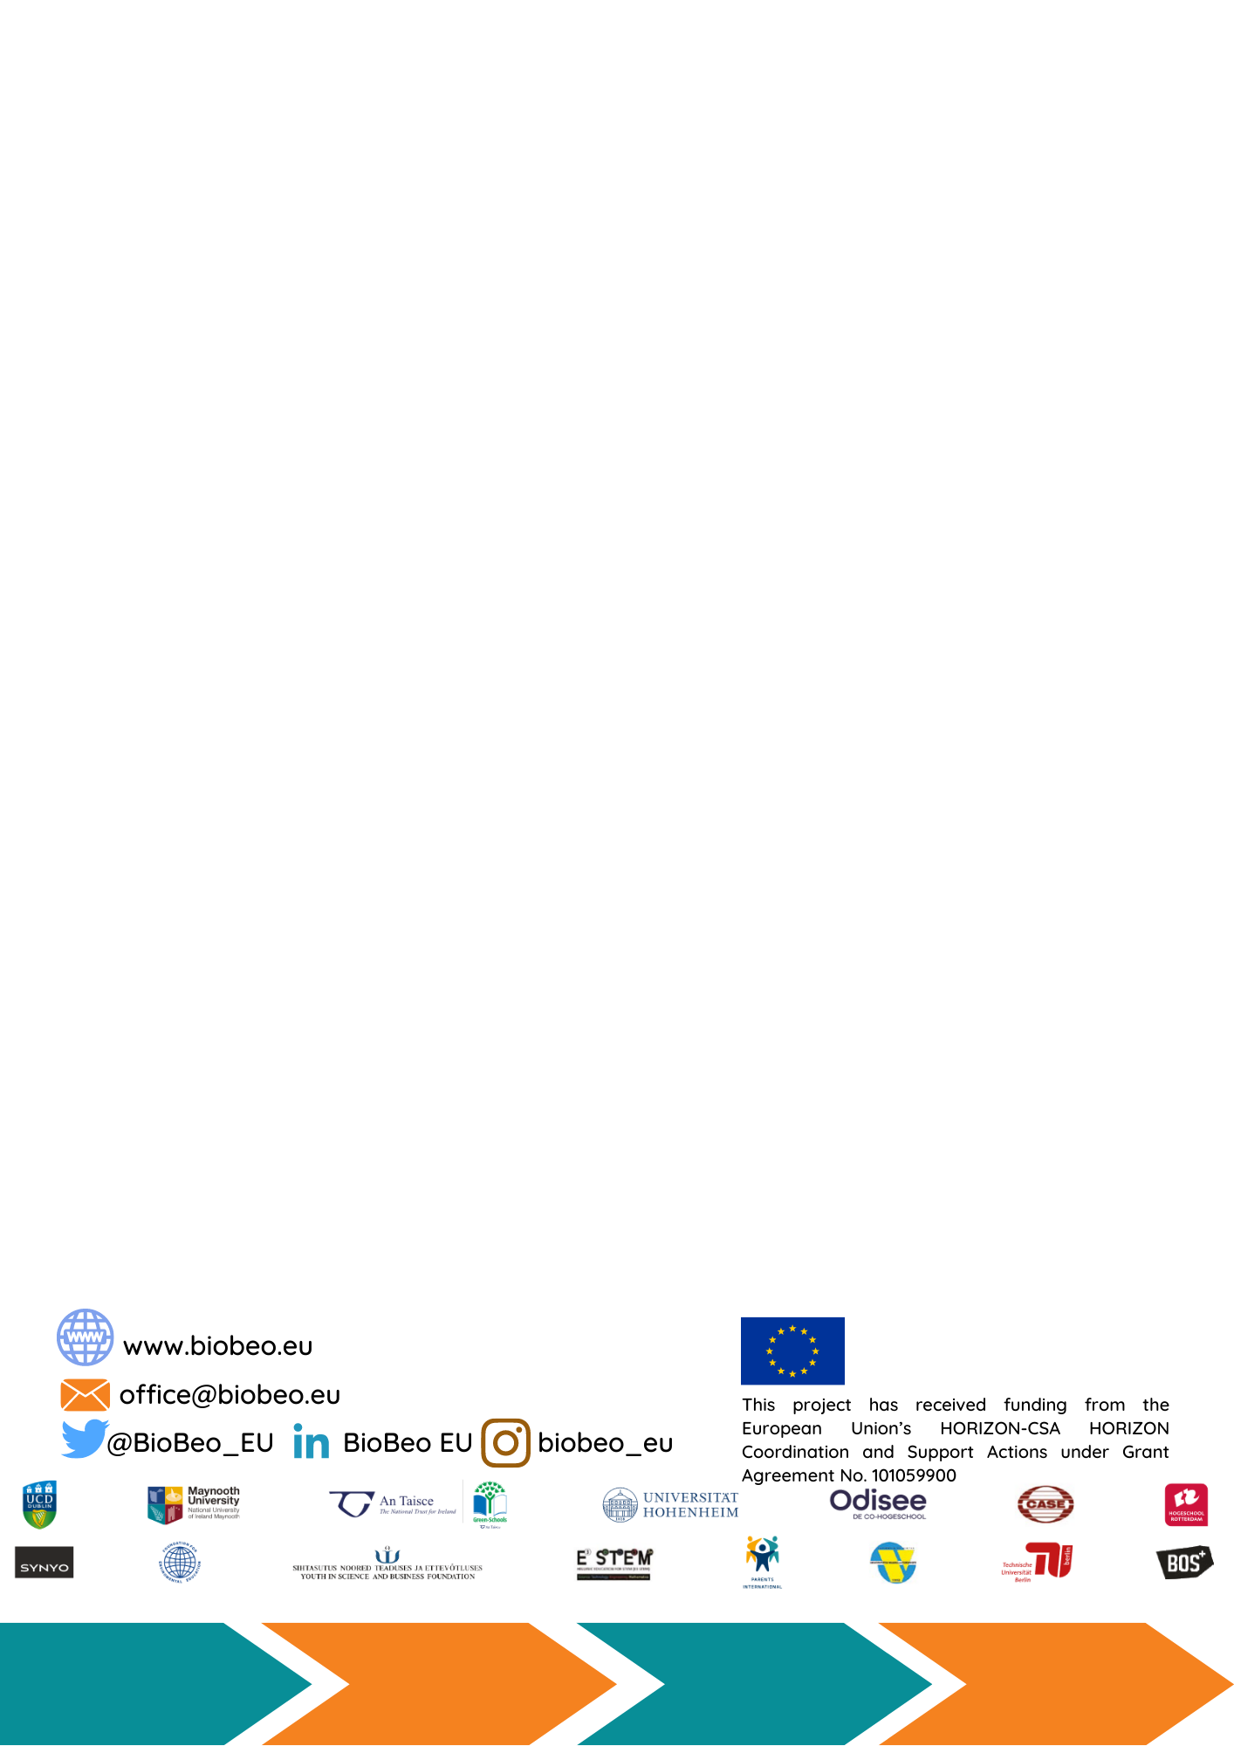

As such, with your collaboration we intend to organise the following events:

* Bioeconomy Day
* Bioeconomy Idea competition targeted at youth aged between 12-18 years old.
* Bioeconomy Workshops

We believe the activities and the outputs developed during the project will highly benefit youth and our society to be more sustainable and circular. Therefore, we request your collaboration in dissemination of BioBeo project and encourage youth to be active participants in the activities.

……Add/ Edit…. As per requirement.

Sign

XYZ